Learn Shell Scripting

1- Hello, World!

The tutorial discusses shell programming in general with focus on Bash

The first line of the shell script file begins with a "sha-bang" (#!) which is not read as a comment, followed by the full path where the shell interpreter is located.

#!/bin/bash

To find out what is currently active shell, and what is its path.

ps | grep $$
987 tty1 00:00:00 bash
This response shows that the shell you are using is of type 'bash'. next find out the full path of the shell interpreter
which bash
/bin/bash

Exercise
Use the "echo" command to print the line "Hello, World!".

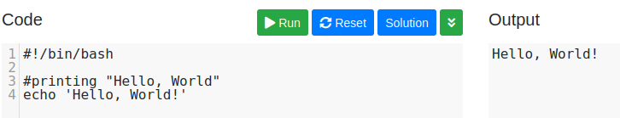

2-Variables

Shell variables are created once they are assigned a value. A variable can contain a number, a character or a string of characters. Variable name is case sensitive and can consist of a combination of letters and the underscore "_". Value assignment is done using the "=" sign. Note that no space permitted on either side of = sign when initializing variables.

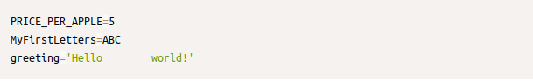
A backslash "\" is used to escape special character meaning
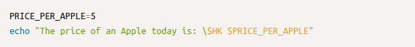
Encapsulating the variable name with ${} is used to avoid ambiguity
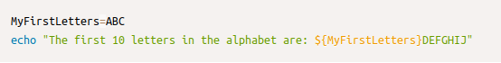
Encapsulating the variable name with "" will preserve any white space values
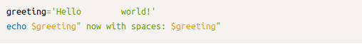
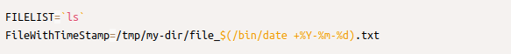
Substitution can be done by encapsulating the command with `` (known as back-ticks) or with $()

Exercise
The target of this exercise is to create a string, an integer, and a complex variable using command substitution. The string should be named BIRTHDATE and should contain the text "Jan 1, 2000". The integer should be named Presents and should contain the number 10. The complex variable should be named BIRTHDAY and should contain the full weekday name of the day matching the date in variable BIRTHDATE e.g. Saturday.
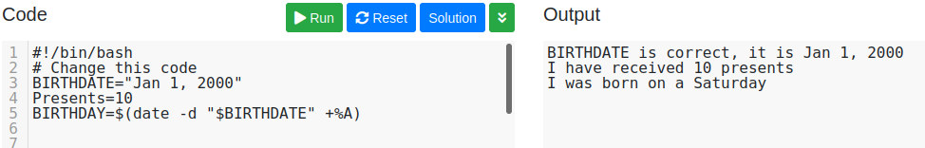
3-Passing Arguments to the Script
Arguments can be passed to the script when it is executed, by writing them as a space-delimited list following the script file name.
Inside the script, the $1 variable references the first argument in the command line, $2 the second argument and so forth. The variable $0 references to the current script.
./bin/my_shopping.sh apple 5 banana 8 "Fruit Basket" 15
echo $3 --> results with: banana
BIG=$5
echo "A $BIG costs just $6" --> results with: A Fruit Basket costs just 15

The variable $# holds the number of arguments passed to the script
echo $# --> results with: 6

The variable $@ holds a space delimited string of all arguments passed to the script.

Exercise
Pass "Shell is fun" (3 arguments) to the script as an array and print the length of the array.
./filename.sh Shell is fun
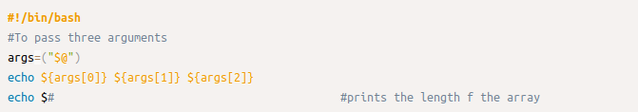
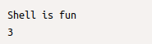
4-Arrays
An array can hold several values under one name. Array naming is the same as variables naming. An array is initialized by assign space-delimited values enclosed in ()
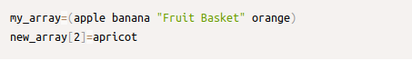

Array members need not be consecutive or contiguous. Some members of the array can be left uninitialized.
The total number of elements in the array is referenced by ${#arrayname[@]}
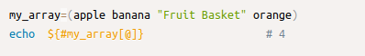

Exercise
In this exercise, you will need to add numbers and strings to the correct arrays. You must add the numbers 1,2, and 3 to the "numbers" array, and the words 'hello' and 'world' to the strings array.
You will also have to correct the values of the variable NumberOfNames and the variable second_name. NumberOfNames should hold the total number of names in the NAMES array, using the $# special variable. Variable second_name should hold the second name in the NAMES array, using the brackets operator [ ].

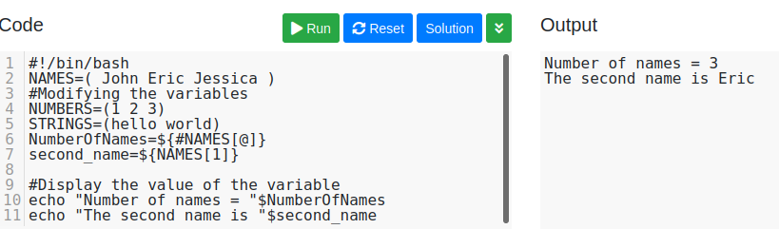

5-Basic Operators

Arithmetic Operators
Simple arithmetics on variables can be done using the arithmetic expression: $((expression))
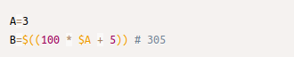

Exercise
In this exercise, you will need to calculate to total cost (variable TOTAL) of a fruit basket, which contains 1 pineapple, 2 bananas and 3 watermelons. Don't forget to include the cost of the basket....
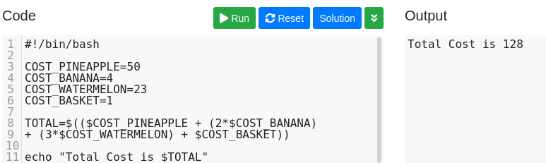

6-Basic String Operations

String Length
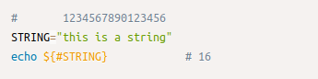

Index
Find the numerical position in $STRING of any single character in $SUBSTRING that matches. Note that the 'expr' command is used in this case.
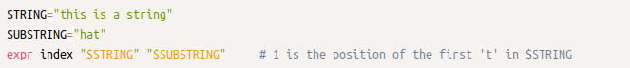

Substring Extraction
Extract substring of length $LEN from $STRING starting after position $POS.
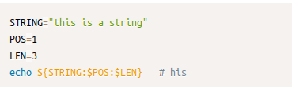

If :$LEN is omitted, extract substring from $POS to end of line
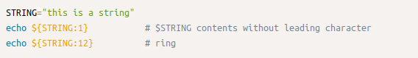

Simple data extraction example:
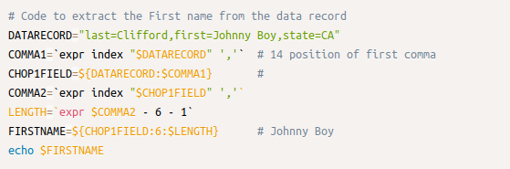

Substring Replacement
Replace first occurrence of substring with replacement
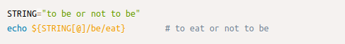

Replace all occurrences of substring
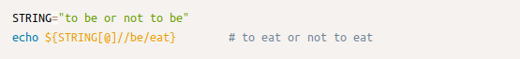
Delete all occurrences of substring (replace with empty string)

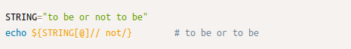

Replace occurrence of substring if at the beginning of $STRING
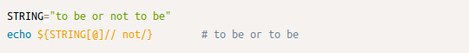
Replace occurrence of substring if at the end of $STRING
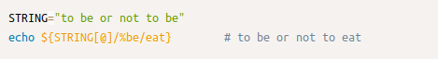

replace occurrence of substring with shell command output
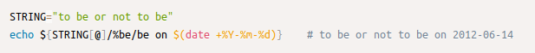

Exercise
In this exercise, you will need to change Warren Buffett's known saying. First create a variable ISAY and assign it the original saying value. Then re-assign it with a new changed value using the string operations and following the 4 defined changes: Change1: replace the first occurrence of 'snow' with 'foot'. Change2: delete the second occurrence of 'snow'. Change3: replace 'finding' with 'getting'. Change4: delete all characters following 'wet'.
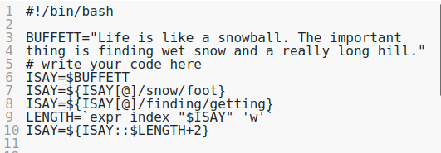

7-Decision Making
if [ expression ]; then
code if 'expression' is true
fi
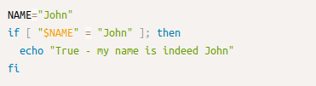

It can be expanded with 'else'
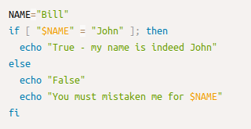

It can be expanded with 'elif' (else-if)
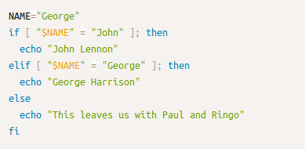

Types of numeric comparisons
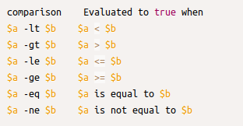

Types of string comparisons
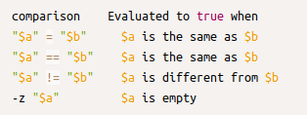

Logical combinations
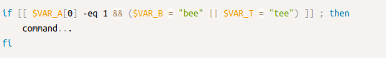

case structure
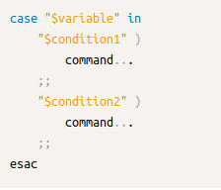

simple case bash structure
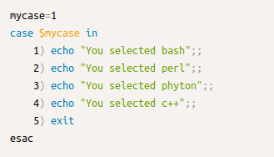

8-Loops
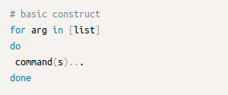

For each pass through the loop, arg takes on the value of each successive value in the list. Then the command(s) are executed.
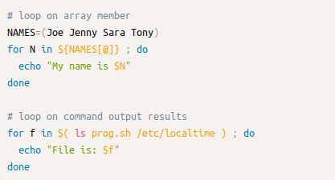

bash while loop
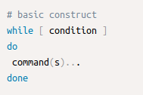

The while construct tests for a condition, and if true, executes commands. It keeps looping as long as the condition is true.
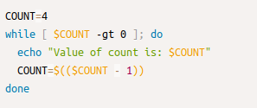

bash until loop
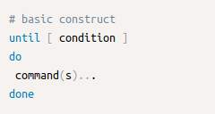

The until construct tests for a condition, and if false, executes commands. It keeps looping as long as the condition is false (opposite of while construct)
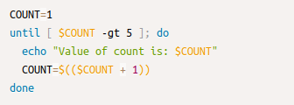

"break" and "continue" statements
break and continue can be used to control the loop execution of for, while and until constructs. continue is used to skip the rest of a particular loop iteration, whereas break is used to skip the entire rest of loop. A few examples:
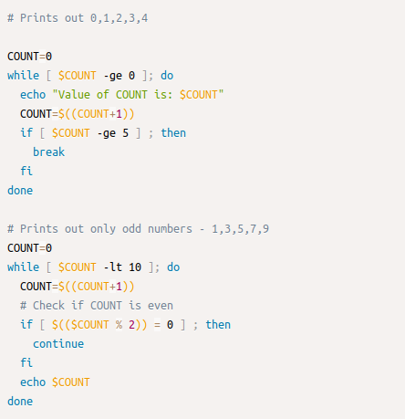

9-Shell Functions
Functions are called simply by writing their names. A function call is equivalent to a command. Parameters may be passed to a function, by specifying them after the function name. The first parameter is referred to in the function as $1, the second as $2 etc.
